|  |  |
| --- | --- |
| **THE Runner GAME** **CONCEPT** The Runner Game is a prototype of the popular **Endless Runner** platformer genre.  In these games, the player runs automatically on a procedurally generated path with one or more lanes. The challenge is to avoid various obstacles and collect various pick-ups. The score is determined based on the distance traveled or on the value of collected items.  For more details about this genre visit Wikipedia:  <https://en.wikipedia.org/wiki/Platform_game#Endless_running_game> | Image result |

# **PROTOTYPE**

The Runner Game prototype must implement the gameplay mechanics specific to this genre.

**The world**

* Must be presented in **3D** with a **perspective camera** following the player
* Must be **procedurally generated indefinitely and randomly**, from prefabricated 3D modules
* Having modules with **left and right turns** of the path is a **bonus**
* Having modules with **2 or 3 lanes** is a **bonus**
* Focus is NOT on art: low poly models or even abstract geometric shapes (cubes) are enough

**The character**

* The player must be presented as a **3D model**
* It must be **animated** by any means that clearly represent his state and actions
* Using Unity’s **Mechanim** system and **skinned meshes** is a **bonus**
* Focus is NOT on art: Unity’s default or free characters and animations are enough (see references)

**The controls**

* The player must **run forward by default**, with a constant speed that is balanced for a fun experience
* The player must be able to **avoid obstacles** with moves specific to each kind of obstacle
* Failing to avoid an obstacle ends the game
* **Keyboard** controls must be supported
* **Gamepad** (xbox 360 controller recommended) support is a **bonus**
* Focus is on the accessibility and fast reflex skills

**The obstacles**

* The game must feature the classic obstacles:
  + **jump** over holes in the path
  + **slide** underneath arches or fallen trees
  + **step sideways** on lanes to avoid rocks in your path
  + move left or right to **take a left or right turn** in the path (if path has turns)
* Feel free to **create your own obstacles** as a **bonus**. Examples:
  + Shoot at a “creature” or wooden barrier in your path, with collected bullets
  + Use a grappling hook with rope to swing over large pits

**The collectibles**

* Featuring **collectible items** (ex. coins) to score is a **bonus**
* These items should be **spawned along the path** randomly and procedurally
* Player should pick these up automatically when colliding with them

**The game flow**

* The game must have a main page from where to start the play session
* During the play session, the player must be able to quit and return to the main page
* During the play session the score and the best score must be displayed
* When the play session ends (player dies), a “game over” message must be displayed
* After that, the game must also return to the main page
* Preserving the best score in a file on disk is a **bonus**

**Other**

* **Sound** effects and **music** are a **bonus**

# **TECHNICAL**



* The [**Unity3D**](https://unity3d.com/) engine will be used for implementation.
* The scripting will be in **C#**.

# **FOCUS**

The main focus of the implementation must be on the **gameplay** and **fun**.   
**Fast reflex skills** must be favored. There must be a **fair challenge** for players to master it. **Technical results** and **code architecture** count, but a good percent of your rating will be based on how close your prototype is to a **good game**.

# **PACKAGE**

You must finish and send your prototype in **24 hours**.

* A functional executable will be provided in a **game.zip** archive.
* The full source (Unity project folder) will be provided in a **game_src.zip** archive.

# **Inspiration**

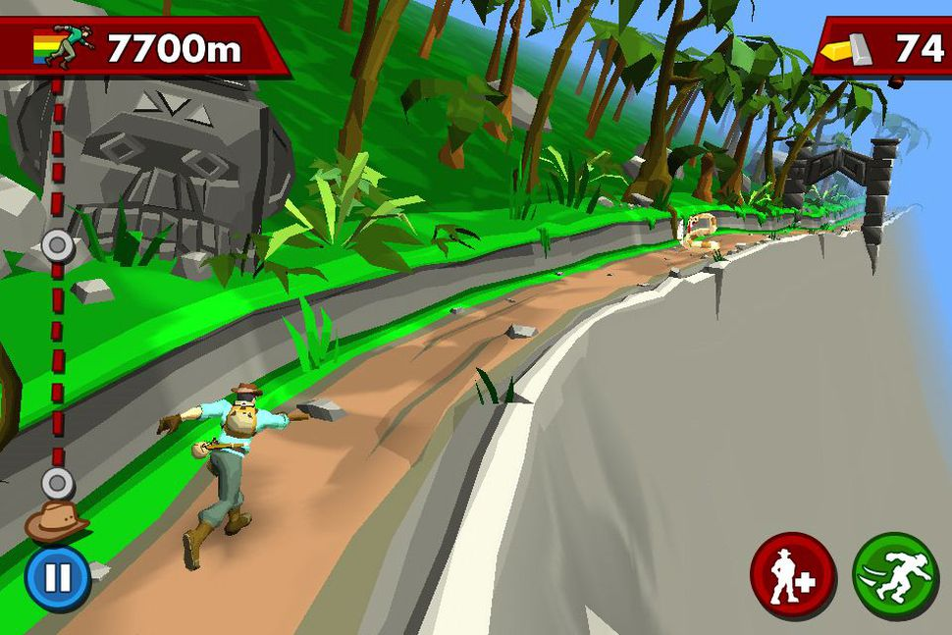 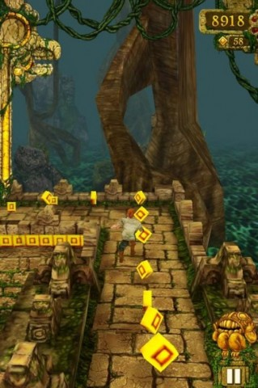 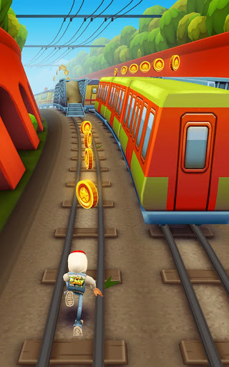

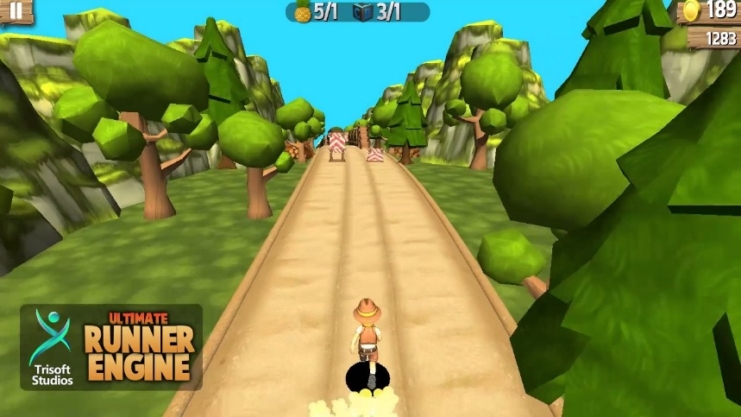 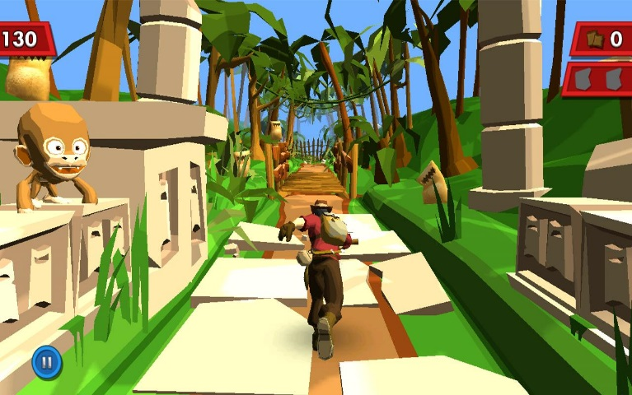

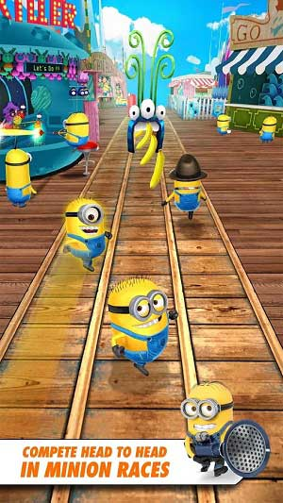 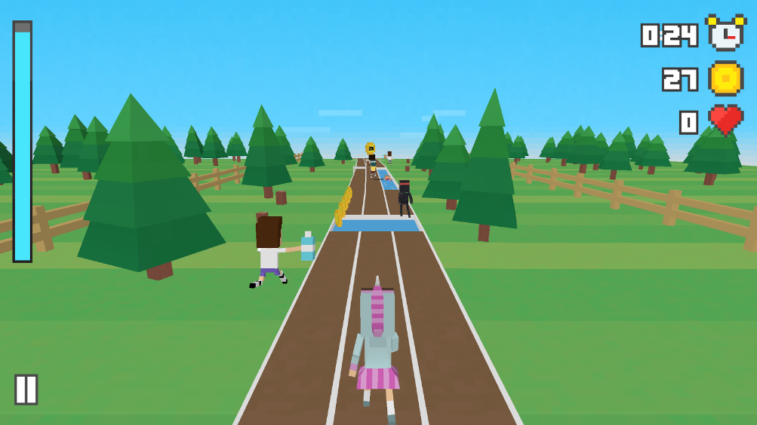

# **RESOURCES**

* Unity Documentation:  
  <https://docs.unity3d.com/Manual/index.html>
* Unity Asset Store  
  <https://assetstore.unity.com>
* Mixamo  
  <https://www.mixamo.com>